**Day 25.10.2024**

1. Area of Triangle using Scanner:

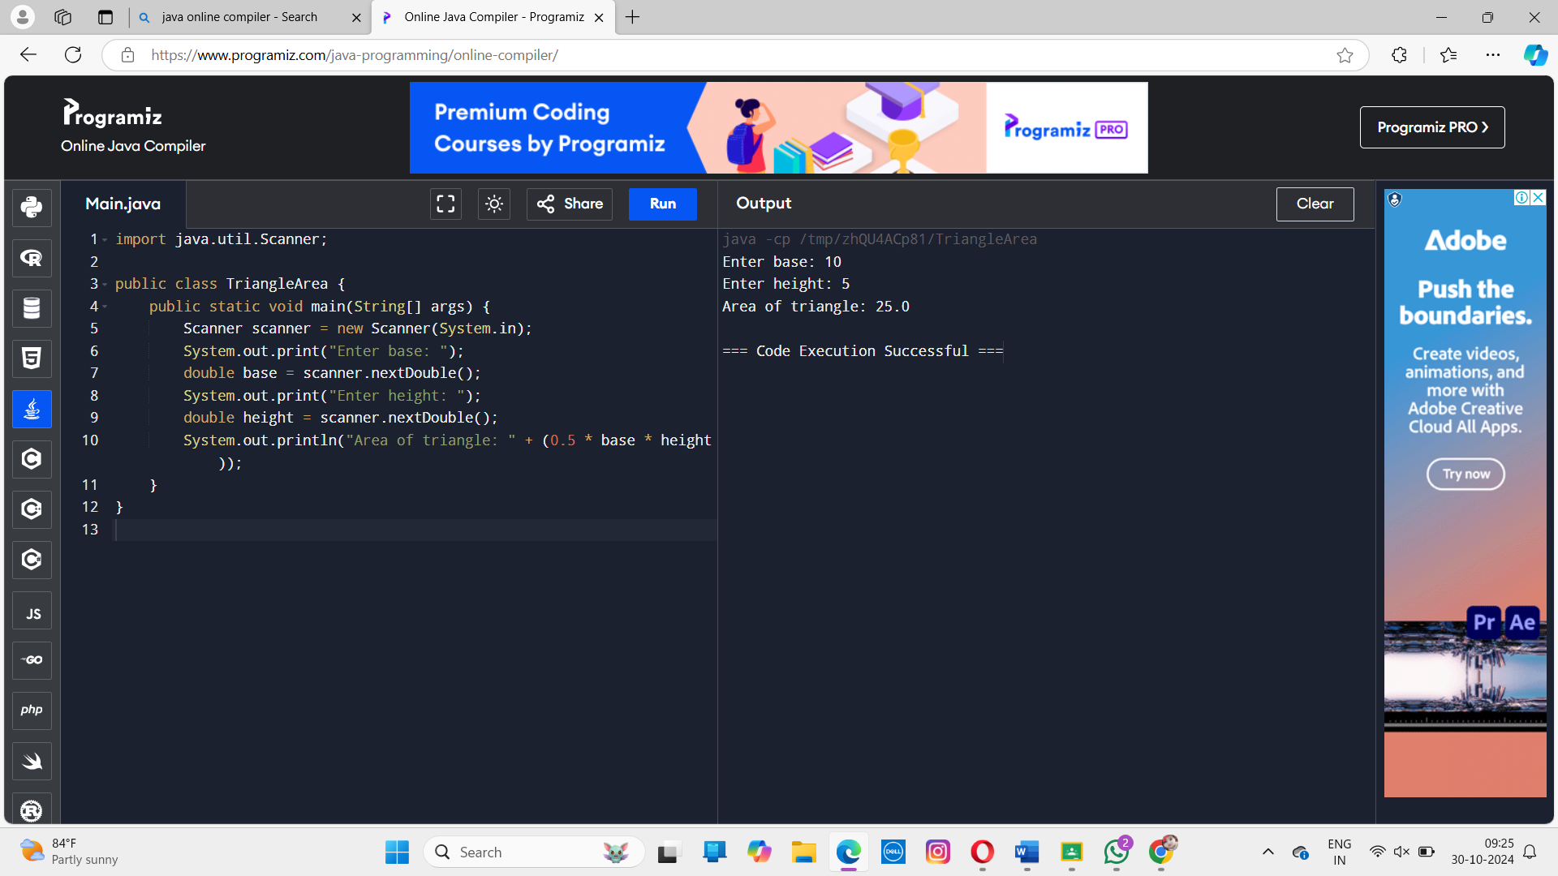

1. Simple Interest using Scanner:

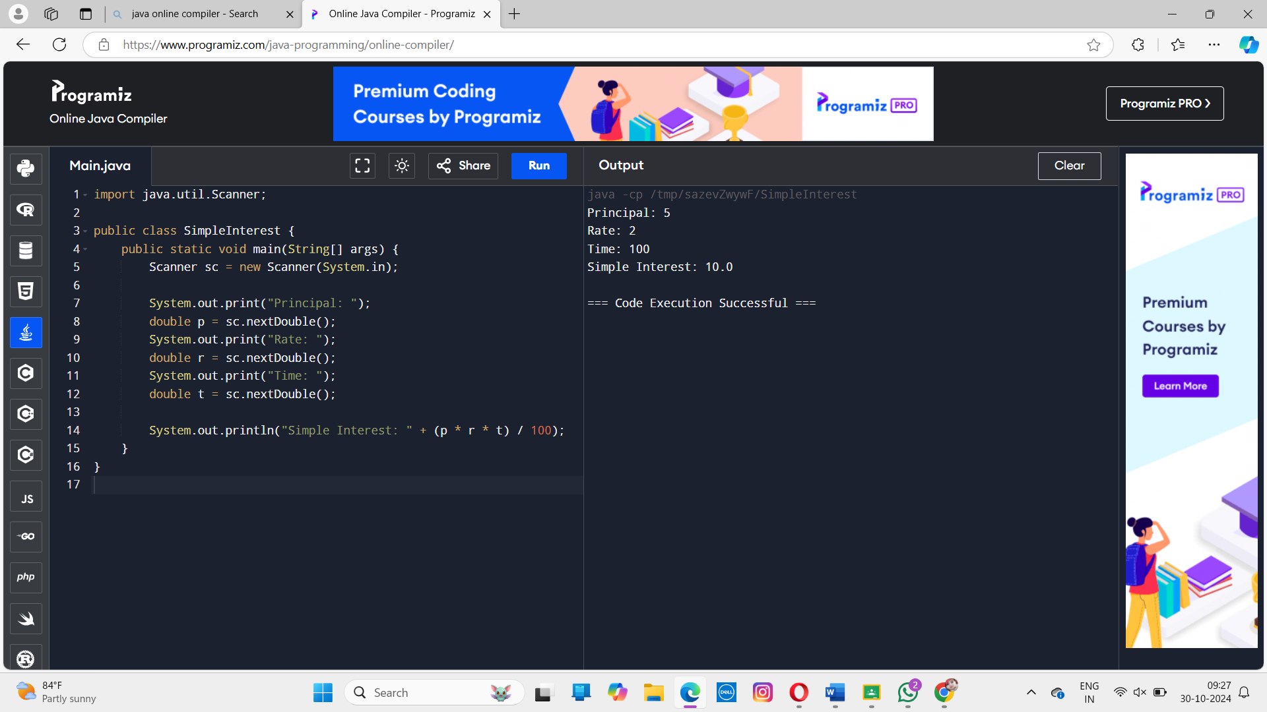

1. Swapping Two Numbers using Scanner:

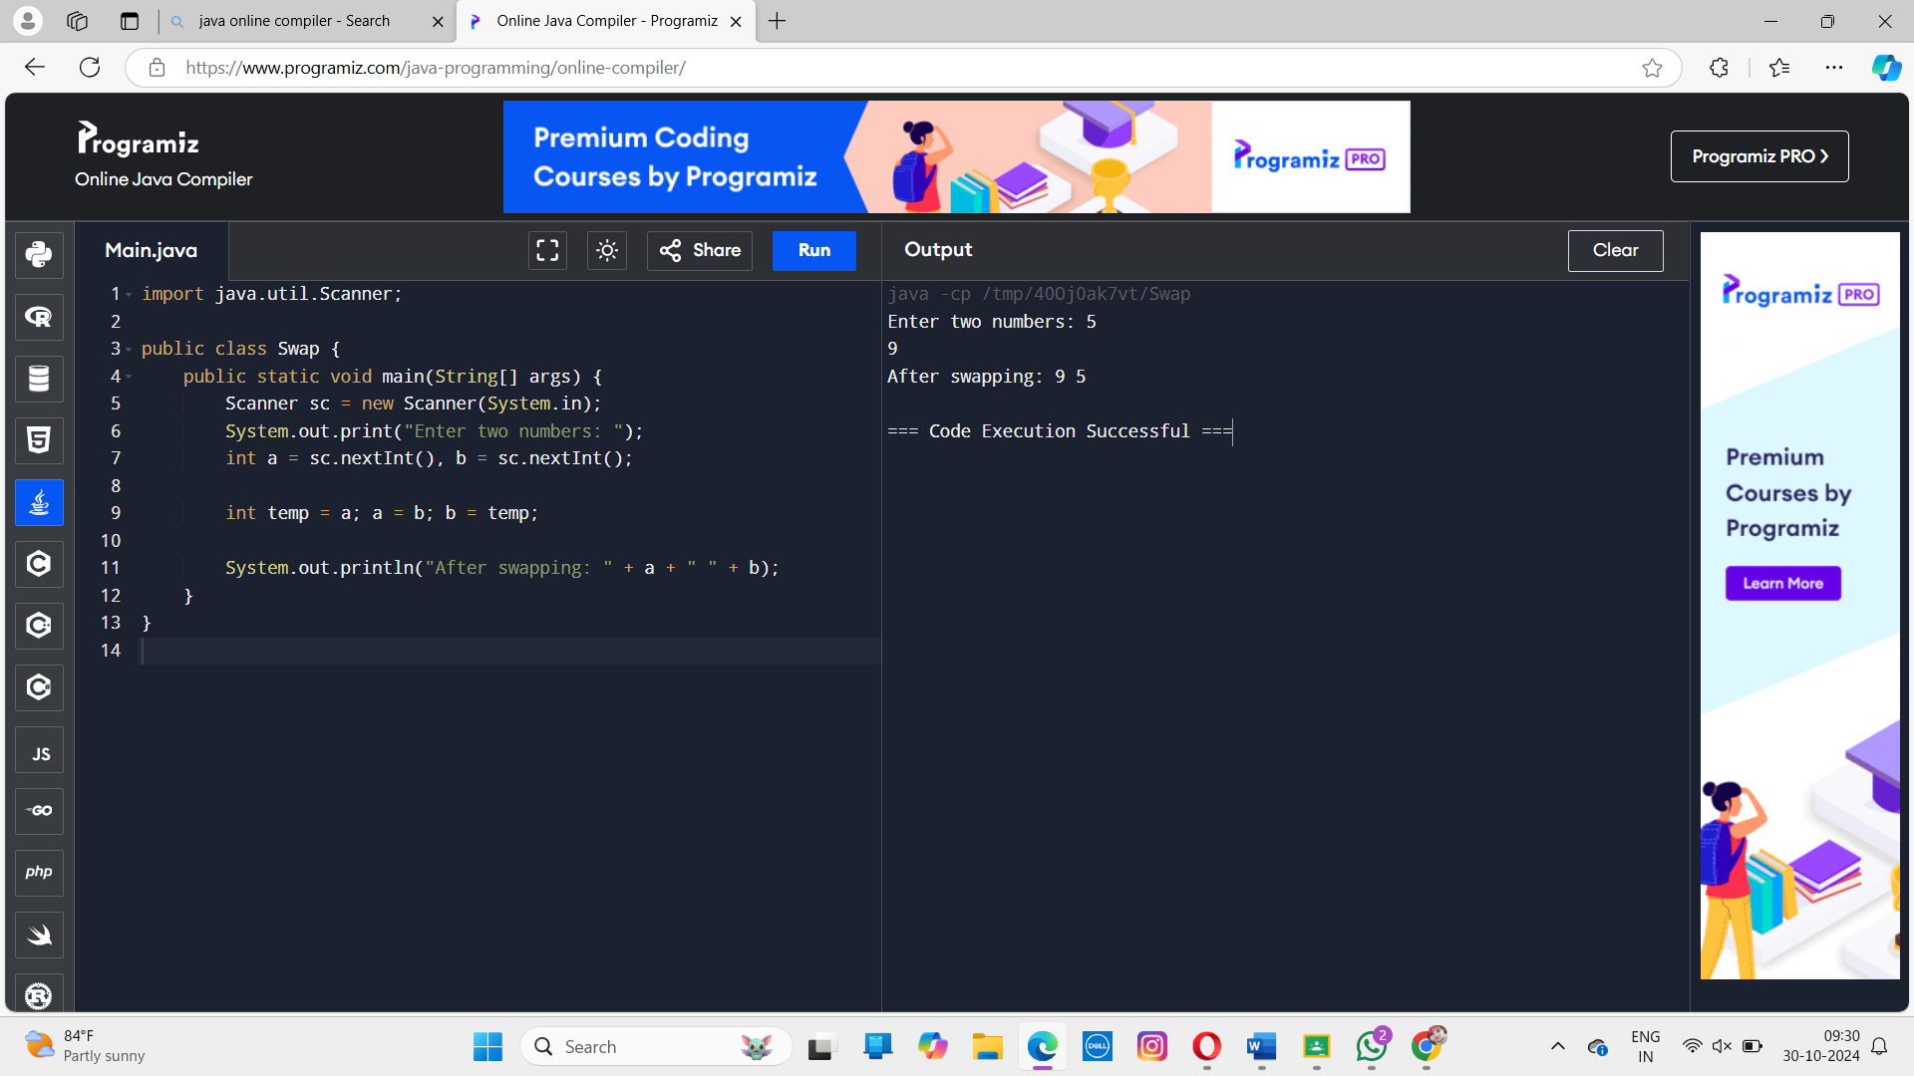

1. Convert Fahrenheit to Celsius using Scanner:

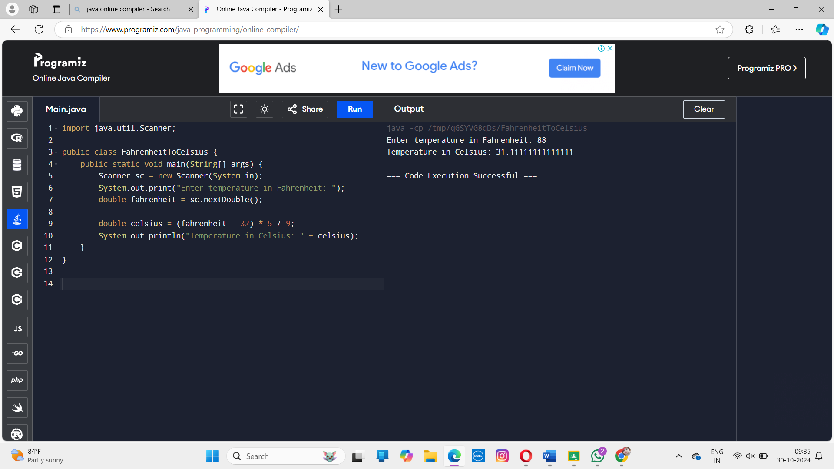

1. Find Quotient and Remainder using Scanner:

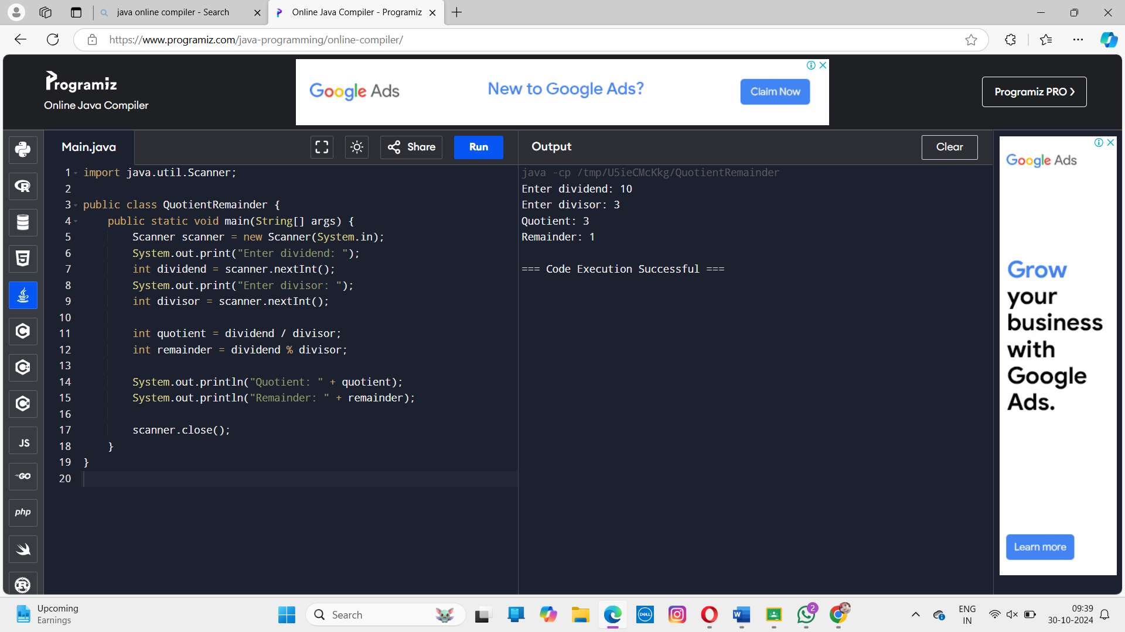

**Assignment2:**

1. Write a Java program to calculate the area of the Rectangle.

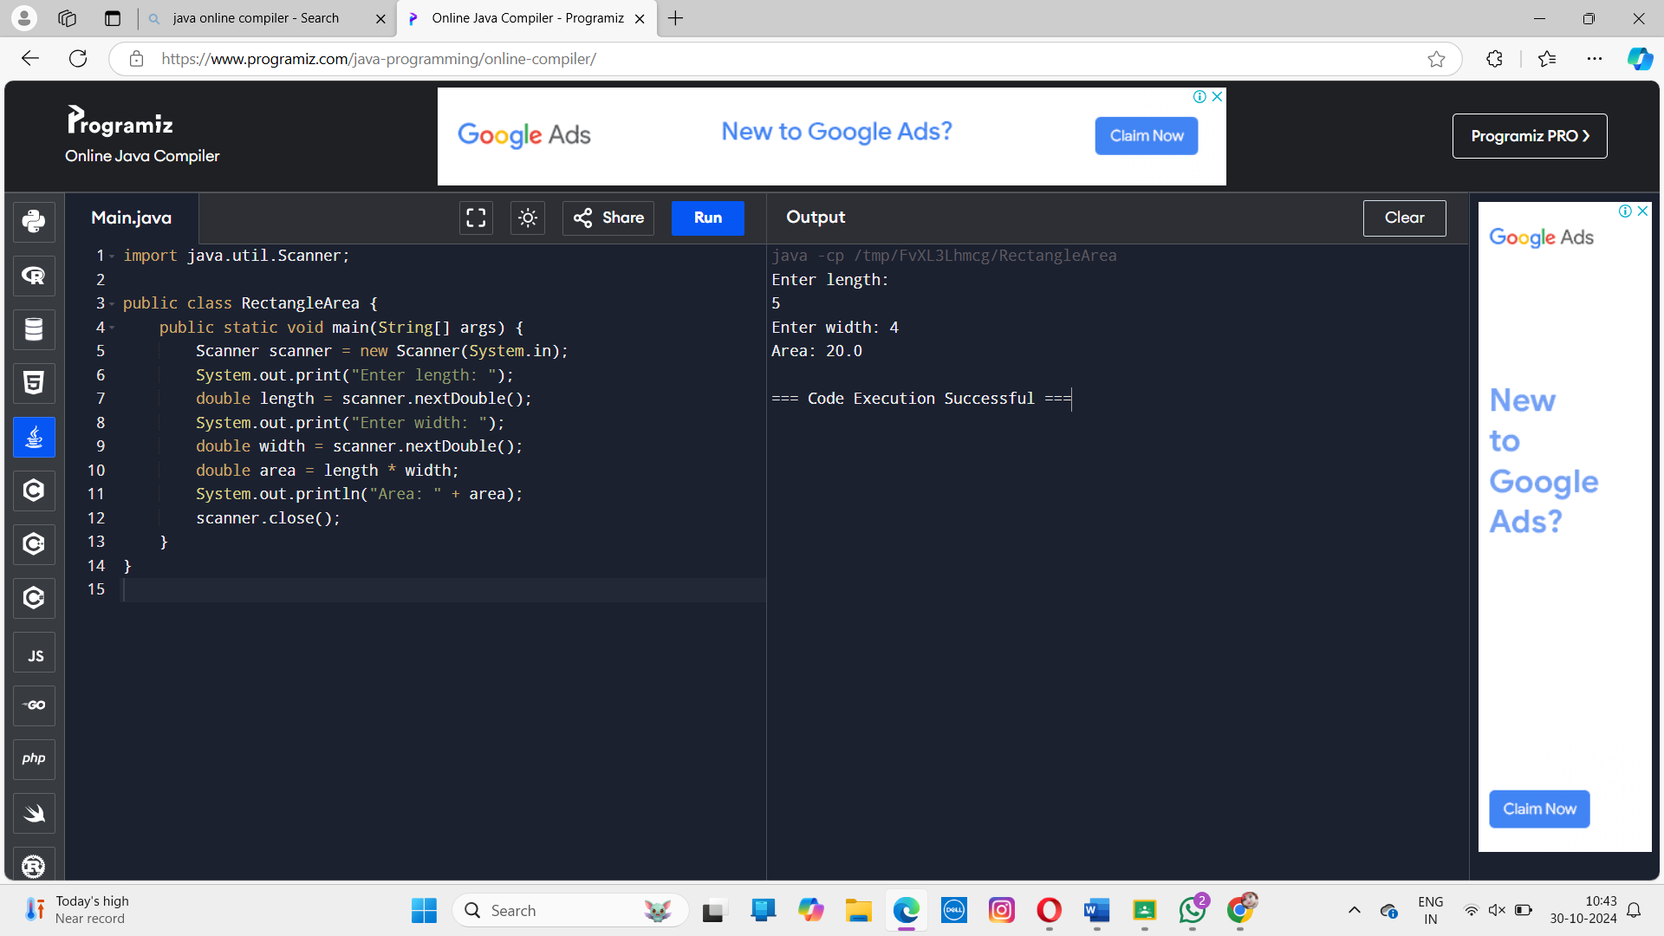

1. Write a Java program to print the sum (addition), multiply, subtract, divide, and remainder of two numbers.

input:

Input first number: 125

Input second number: 24

Output: 149, 3000, 101, 5, 5

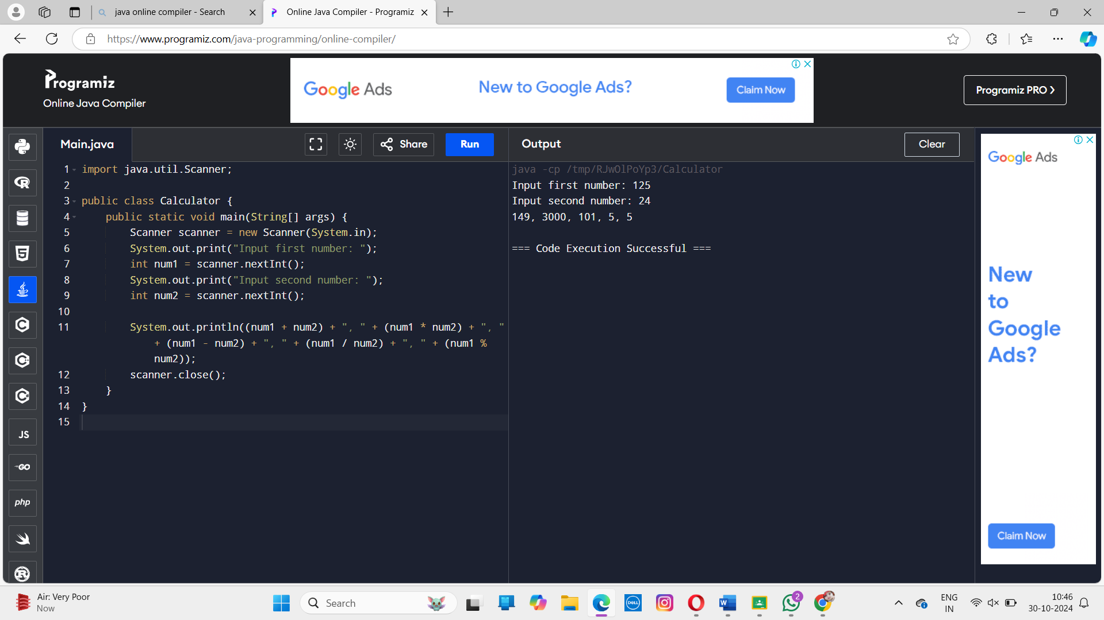

1. Write a Java program that reads a floating-point number and displays the square, cube, and fourth power.

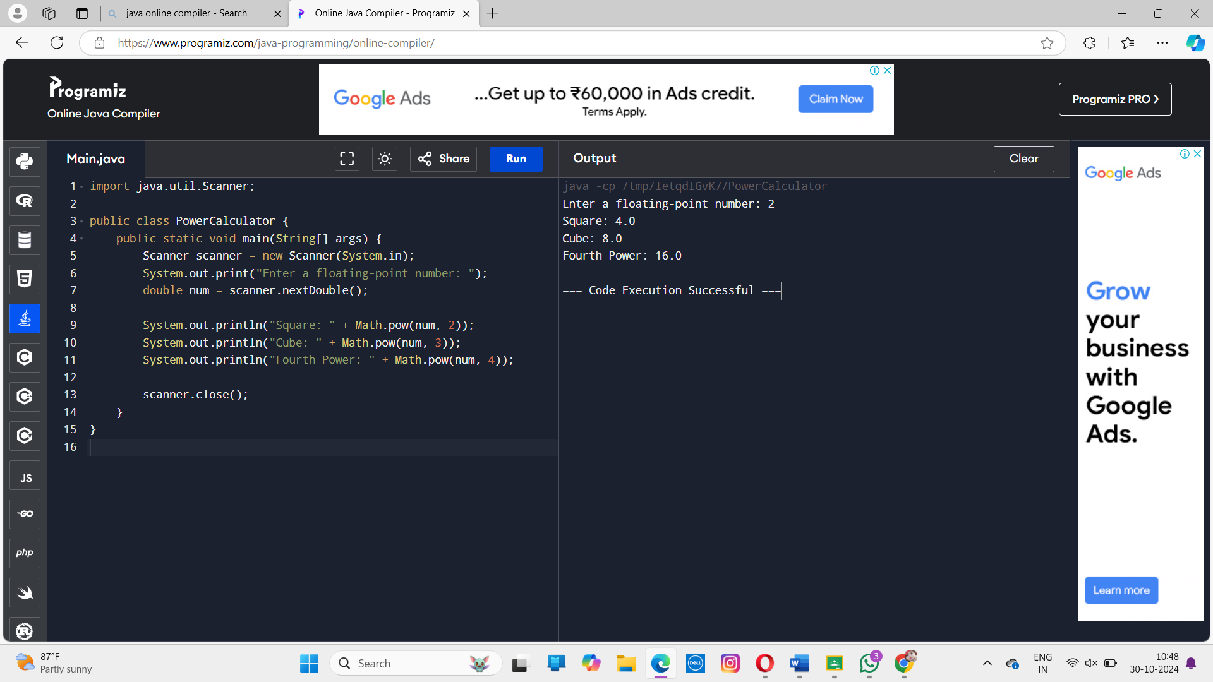

1. Write a Java program that reads a number in inches and converts it to meters.

Note: One inch is 0.0254 meters.

Input:

Input a value for inch: 1000

Output:

1000.0 inches is 25.4 meters

